**Exploring ChatGPT: Threats, Mechanism, Potential and the Future of GenAI.**

Dishant Uprety

BSc Computer Science & Mathematics

St. Joseph’s University, Bengaluru India

**ABSTRACT**

With the introduction of ChatGPT in November 2022 revolutionized the field of Artificial Intelligence. ChatGPT is based on a large amount of pre-existing data that it uses to learn patterns and context in language. It is trained with 175 billion parameters and around 500 billion tokens and has the capability to understand and generate human-like text. However, its rapid growth raises questions regarding the threats, mechanisms, potential and future implications of Generative Artificial intelligence (GenAI). This paper explores ChatGPT in multiple ways examining its architecture, capabilities, limitations, potential of the application, threats to the people, and implications of GenAI in the future. The paper begins by exploring its applications in various fields followed by the technical and architecture of ChatGPT. Additionally, the paper discusses ethical concerns, privacy, and the future. Thus, in this paper, we embark on a comprehensive exploration of ChatGPT, investigate its underlying architectural structure, and explore the limitations, threats and potentials and the future implications of GenAI. We explore by analysing existing research papers and in-depth investigation, making the paper simple and understandable by anyone.

**KEYWORDS**

ChatGPT, Generative AI, Natural Language Processing, Transformers Architecture, Self-Attention, Multi-Head Attention, Positional Embedding, Feed-Forward Neural Network, Reinforcement Learning Through Human Feedback.

**INTRODUCTION**

The advancement in artificial intelligence led to the development of a natural language processing chatbot that can generate a human-like language. This is the ChatGPT introduced by OpenAI on the 30th of November 2022. The ChatGPT represent the success in the field of GenAI and Natural Language Processing. With its ability to understand and generate human-like text, it has become a revolution in the field of Conversational AI. It is versatile and has been adopted in various domains or fields of application. ChatGPT has set a record for the highest-growing application. The adoption, accessibility, and technology are the reasons for the proliferation of ChatGPT.

The introduction of Transformer Architecture in the paper” Attention is all you need” laid the foundation of ChatGPT – Chat Generative Pre-Trained Transformer. It is a Natural Language Processing technology and is trained by OpenAI. ChatGPT has about 175 billion parameters and it is spread across 96 layers in the neural networks. The source datasets contain 500 billion tokens. It is designed as an autoregression framework i,e it can achieve task-agnostic goals using a few-slot learning paradigm. The model can adapt to various tasks with minimum data and can generate human-like texts as it is trained on a large amount of data from the internet. It has the ability to engage in conversational interactions with the users. This capability of ChatGPT has various uses for applications like customer service support, context generation, creative writing, text summarization, educational tools etc. ChatGPT has also been exceptional in the field of art demonstrating its ability to generate beautiful poems in a very short period. The ability of ChatGPT to understand and generate human-like text makes it a valuable tool in many fields.

While ChatGPT has demonstrated remarkable capabilities in generating human-like text, it also has limitations like limited contextual understanding, bias outputs, difficulty with long texted context, sensitive data or personal data etc. We will discuss some detailed limitations of ChatGPT in the later part of the paper.

In the rapid growth of groundbreaking technology which provides opportunities for guidance and innovation, the adoption of ChatGPT raises some significant concerns regarding potential threats and risks. Some of the potential threats are misinformation, privacy risks, biases, ethical concerns etc. We will discuss and find out the potential threats and risks of ChatGPT by doing in-depth investigations and by asking different questions to the ChatGPT using various prompts.

As GenAI is the foundation of all LLMs and Natural Language Processing (NLP), it is important to understand GenAI, its technology, application, potential threats and risks, and future implications. GenAI or Generative Artificial Intelligent is basically a subset of Deep Learning. It uses artificial neural networks and can process both labelled and unlabelled data using supervised, unsupervised and semi-supervised learning. GenAI can produce various types of contexts including text, imagery, audio and synthetic data. It is used in various domains of application. With the advancement in the field, the future of GenAI is promising. In the paper, we will do an overview of Generative Artificial Intelligence (GenAI).

**Literature Review**

[1] "**Attention Is All You Need**"

Authors: Ashsih Vasmani, Noam Shazeer, Niki Parmar, Jakob Uszkoreit, Llion Jones, Aidan N. Gomez, Lukasz Kaiser, Illia Polosukhin

Published in Advances in Neural Information Processing Systems 30, 2017

"Attention is All You Need" is a groundbreaking paper in the field of artificial intelligence, specifically in natural language processing. It introduces a new neural network architecture called the Transformer which marks a significant departure from traditional architectures by relying solely on attention mechanisms instead of recurrent layers. This architecture has had a significant impact on various tasks, including machine translation, and text generation, and enables faster training times compared to models based on recurrent or convolutional layers, particularly beneficial for translation tasks.

The authors demonstrate the Transformer's prowess by achieving state-of-the-art results on the WMT 2014 English-to-German and English-to-French translation tasks. Their best model surpasses previous ensemble models, showcasing the Transformer's superiority in capturing complex language patterns and nuances.

The authors aim to extend the Transformer's capabilities to handle input and output modalities beyond text, such as images, audio, and video. Additionally, they propose exploring local, restricted attention mechanisms to efficiently process large inputs and outputs. Moreover, the authors aspire to make generation less sequential, which could lead to significant advancements in various domains relying on sequential data processing.

In summary, "Attention is All You Need" presents a transformative model that not only achieves exceptional performance in translation tasks but also lays the groundwork for future advancements in diverse areas of artificial intelligence, from multimodal processing to more efficient attention mechanisms.

[2] "**A Brief Overview of ChatGPT: The History, Status, Quo and   
 Potential Future Development"**

Authors: Tianyu Wu, Shizhu He, Jingping Liu, Siqi  
Sun, Kang Liu, Qing-Long Han, Yang Tang

Published in IEEE/CAA Journal of Automatica Sinica 10(5),1122-1136,2023

The paper provides an overview of ChatGPT, an AI agent developed by OpenAI, discussing its predecessor, strengths, limitations, social impact, and potential future development. It investigates into the core techniques of ChatGPT, which include large-scale language models, in-context learning, reinforcement learning from human feedback, and their potential interrelations. ChatGPT is hailed as a significant technology product with importance in both academic and industry domains.

However, the paper also raises questions about how ChatGPT achieves its powerful functions using relatively simple algorithmic components such as gradient descent, large-scale language models built with Transformers, and vast amounts of data. It suggests that future research should investigate the phenomenon of emergence in large language models to understand its implications and potential abilities.

The paper highlights the growing interest among companies and research groups in developing ChatGPT-like products or AI and Generative Computing (AIGC) products. Examples include Microsoft's integration of ChatGPT with the Bing search engine, Baidu's ERNIE Bot for generating images from text descriptions, and Sensetime's SenseChat robot capable of generating various media contents. ChatGPT-related technologies have garnered global attention and are becoming a significant force in computer science.

However, the essence of ChatGPT-like products is emphasized to be a form of AIGC rather than achieving artificial super intelligence (ASI). The paper suggests that attention should be given to the potential side effects of such technologies, such as the reliability and validity of AI-generated answers and the risk of cheating. It emphasizes the importance of consensus on ethical and responsible usage as people continue to anticipate advancements in artificial intelligence.

[3] **"A Brief Analysis of the Architecture, Limitations and Impacts of ChatGPT"**

Authors: Noah M Kenny

Published in ResearchGate, March, 2023

The paper provides a comprehensive overview of ChatGPT, covering its technical architecture, current use cases, analysis of limitations, and impacts.

Technical Architecture:

This part of the paper illustrate that ChatGPT utilizes a large number of parameters, reinforcement learning, supervised learning, and a vast training dataset to effectively generate text. The use of reinforcement learning allows ChatGPT to improve its accuracy over time based on user feedback. Supervised learning is employed for classification and regression tasks, helping ChatGPT understand and respond to user queries accurately.

Current Use Cases:

ChatGPT is utilized for coding, conversational AI, and content generation across various domains. It can write code in multiple programming languages, provide conversational responses, and generate text for different purposes, including blog posts, articles, and advertisements.

Analysis of Limitations:  
ChatGPT lacks creativity and personal experience, operating within predefined parameters. There are concerns about inherent bias in AI models like ChatGPT, which may reflect the demographics of the developers. Identification of content written by ChatGPT and the distinction between AI-generated and human-generated content pose challenges.

Impacts of ChatGPT:

Copyright considerations arise regarding ownership and originality of content generated by ChatGPT. In higher education, ChatGPT's use raises questions about academic integrity and the balance between producing educated individuals and skilled workers. Economic considerations include the potential for ChatGPT to augment or replace human labour, leading to discussions about unemployment and economic implications.

Overall, this paper provides a thorough examination of ChatGPT, highlighting its capabilities, limitations, and broader implications across various domains. It addresses technical aspects, ethical considerations, and societal impacts, offering valuable insights into the role of AI in contemporary contexts.

[4] "**ChatGPT and OpenAI Models: A Preliminary Review**"

Authors: Konstantinos | Roumeliotis, Nikolaos D

Published in Future Internet 15(6), 192, 2023

In this paper, the authors illustrate how ChatGPT represents a significant advancement in AI, capable of generating human-like text responses. The technology has garnered substantial attention due to its capabilities in natural language processing and coding assistance. This article aims to provide a comprehensive overview of ChatGPT by exploring its history, training process, and emerging applications.

ChatGPT's development involves extensive training with vast amounts of data, enabling it to understand and generate text in a manner resembling human communication. Furthermore, it possesses the capability to generate code and algorithms, facilitating tasks such as code error identification and resolution. Understanding the history and training process of ChatGPT is crucial for comprehending its capabilities and limitations.

To provide a comprehensive understanding of ChatGPT, the authors conduct a systematic literature review encompassing forty-seven articles. These articles are categorized into eleven research domains, reflecting the diverse applications and implications of ChatGPT. By structuring the literature review in this manner, the article aims to highlight the breadth and depth of research conducted on ChatGPT.

In conclusion, this paper offers valuable insights into the advantages and disadvantages of ChatGPT, as well as potential areas for further research and development. Additionally, the paper serves as a valuable resource for researchers.

[5] **"Can ChatGPT Understand Too?  
 A Comparative Study on ChatGPT and Fined-Tuned BERT”**

Authors: Qihuang Zhong, Liang Ding, Juhua Liu, Bo Du, Dacheng Tao

Published in arXiv preprint arXiv:2302.10198,2023

This study empirically investigates ChatGPT's language understanding ability across a range of natural language understanding (NLU) tasks. The objective is to assess ChatGPT's performance on tasks such as inference, paraphrasing, and similarity, identifying areas where it excels and areas where it falls short. Additionally, the study aims to explore methods for enhancing ChatGPT's understanding ability through advanced prompting strategies.

The study employs a series of experiments to evaluate ChatGPT's performance on various NLU tasks. These tasks include inference, paraphrase detection, and similarity assessment. The researchers conduct thorough analyses, particularly focusing on the model's performance on negative instances of these tasks. Additionally, they experiment with advanced prompting strategies aimed at improving ChatGPT's understanding ability.

The findings reveal that ChatGPT performs well on inference tasks but struggles with paraphrase and similarity tasks, particularly with negative instances. However, the study demonstrates that the implementation of advanced prompting strategies leads to significant performance improvements for ChatGPT.

In conclusion, the study provides valuable insights into ChatGPT's language understanding ability and its potential for improvement.

[6] **"Exploring ChatGPT Capabilities and Limitations: A Survey"**

Authors: Anis Koubaa, Wadii Boulila, Lahouari Ghouti, Ayyub Alzahem, Shahid Latif

Published in IEEE Access, 2023

This survey provides a critical review of ChatGPT, focusing on its technical advancements and its position within the conversational and generative AI landscape. Through a comprehensive analysis, the survey aims to unravel the factors contributing to ChatGPT's exceptional performance and capabilities. It achieves this by examining its innovations, categorizing recent research, and conducting a comparative analysis of its competitors.

The survey helps to clarify ChatGPT's performance by investigating into its technical innovations and advancements. By dissecting its architecture and algorithms, the survey sheds light on the underlying mechanisms driving ChatGPT's success in generating human-like text responses. This provides valuable insights into the complex features of ChatGPT's functioning and its implications for conversational and generative AI.

In addition to highlighting ChatGPT's strengths, the survey also identifies and discusses its challenges and limitations. By critically examining areas for improvement, the survey underscores the importance of addressing gaps in ChatGPT's capabilities

In conclusion, the survey lays the groundwork for a deeper understanding of ChatGPT in the context of generative AI. It serves as a valuable reference for researchers and practitioners seeking to leverage ChatGPT in their applications or address its limitations through ongoing development efforts.

[7] **"Exploring ChatGPT and its Impact on Society"**  
 Authors: Md Asraful Haque, Shuai Li  
 Published in Al and Ethics, 1-13, 2024

This paper provides a comprehensive overview of the capabilities, potential, and challenges associated with ChatGPT, an advanced natural language processing tool. ChatGPT is introduced as a highly popular and transformative technology that simplifies and accelerates various tasks. It is described as an evolved language model with the potential to revolutionize human-technology communication by understanding complex language patterns and generating human-like responses.

The paper highlights the diverse applications of ChatGPT across different industries, including customer service, content creation, language translation, and education. It emphasizes how ChatGPT facilitates accessibility to information and aids students in understanding complex subjects through conversational explanations.

While acknowledging the immense promise of ChatGPT, the passage also raises concerns about potential challenges such as biases, misinformation, privacy issues, and ethical dilemmas.

The passage advocates for a human-centric approach to ChatGPT promotion and deployment, highlighting the importance of supplementing rather than replacing human capabilities. By prioritizing human needs, concerns, and values, it aims to ensure the responsible and ethical deployment of conversational AI technology.

[8] **"ChatGPT: Applications, Opportunities and Threats**"  
Authors: Aram Bahrini, Mohammadsadra Khamoshifar, Hossein Abbasimehr, Robert J. Riggs, Maryam Esmaeili, Rastin Mastali Majdabadkohne, and Morteza Pasehvar.  
Published in 2023 Systems and Information Engineering Design Symposium(SIEDS),274-279,2023

This passage provides an overview of the examination of ChatGPT's evolution, applications, opportunities, and threats, with a particular focus on its implications for business, industry, and education. The paper introduces the paper's focus on the evolution of ChatGPT and its exploration in various domains, particularly business, industry, and education. It highlights the significance of ChatGPT in revolutionizing natural language processing and its potential to streamline tasks and save resources.

The paper also mention an experiment conducted to assess the effectiveness of GPT-4. This experiment likely aimed to evaluate how ChatGPT could be utilized in educational settings to enhance learning outcomes or facilitate teaching processes.

The paper also emphasizes the importance of recognizing and mitigating potential threats associated with its usage. These threats include the production of misleading results, biases, ethical concerns, and misuse. The paper discusses the limitations of AI, noting that while ChatGPT and similar models have impressive capabilities, they are unlikely to completely replace humans in all tasks and situations. It suggests that tasks requiring human qualities such as intuition, emotion, creativity, and intelligence may still require human involvement. However, AI can assist humans in generating ideas and insights and may contribute to the creation of new concepts with human input.

Thus, the paper concludes by summarizing the key points discussed, highlighting the importance of responsible use of ChatGPT and recognizing the complementary roles of AI and humans in various tasks and scenarios.

[9] **"What Do We Mean by GenAI?   
A Systematic Mapping of The Evolution, Trends and Techniques Involved in Generative AI"**  
Authors: Francisco Garcia-Penalvo, Andrea Vazquez-Ingelmo  
Published in International Journal of Interactive Multimedia and Artificial Intelligence, 2023

The paper presents the findings of a literature mapping exercise focused on AI-driven content generation. Through analysis of 1963 unique works, the researchers identified 631 articles to gain insights into the landscape of generative AI solutions. They found a notable trend in the use of specific models like GANs and encoder-decoder networks for generating various resources, particularly images and tabular data. These solutions are primarily employed to augment datasets and improve the predictions of subsequent models.

The study observes a shift in the generative AI landscape due to the emergence of commercial solutions, with a slight increase in solutions focused on text generation. However, this expansion also brings new ethical dilemmas. In domains such as education, the integration of generative AI tools is met with both excitement and concern. While AI has the potential to transform pedagogical methods and improve learning experiences, there are concerns regarding issues like assessment, academic integrity, and data privacy. Similarly, in software development, AI-driven code generation offers benefits such as speeding up processes and reducing debugging time. However, there are apprehensions about potential job displacement and ethical implications related to accountability and transparency in AI-generated code.

The paper suggests that a deeper understanding of generative AI can help address acceptance issues and challenges more effectively. By defining generative AI as a process of generating new content from existing resources through generative modelling, it emphasizes the importance of viewing AI as a data-driven tool rather than an omnipotent solution. This pragmatic approach can help set realistic expectations and facilitate the integration of AI into various domains.

In conclusion, the paper highlights the need for a nuanced understanding of generative AI to navigate its potential benefits and challenges successfully, while also managing societal expectations and ethical concerns.

**OBJECTIVES**

* **Provides an Overview:** It offers a comprehensive introduction to ChatGPT, including its definition, purpose, and key features. Explaining how ChatGPT functions as a language generation model and its significance in the field of artificial intelligence.
* **Technical Understanding**: This paper aims in understanding the architecture of ChatGPT including the transformer architecture, self-attention mechanism, fine-tuned model and the training methodology illustrating the mechanism.
* **Potential and Threats**: This paper discusses about the Potentials and Threats of ChatGPT, including the ability to understand and generate human-like texts and the limitations in handling complex queries, biases, etc.
* **GenAI**: This paper aims to do an overview of GenAI, understanding its capabilities, threats and future implications in brief.

**Existing System**

In this part, we will discuss the architectural structure, threats, potentials of ChatGPT and do an overview of Generative Artificial Intelligence.

* **Architecture of ChatGPT**

The heart of the ChatGPT is LLM or Large Language Model. LLM is a type of neural network base model that is trained on a massive amount of text data to understand and generate human language. The largest model of GPT has 175 billion parameters (different features of the language model) spread across 96 layers of the neural networks. Successful techniques including pre-normalization, reverse tokenization, and modified initialization form the foundation of the GPT training process. However, GPT-3 also introduces a new refinement based on alternating dense and sparse attention patterns. All the GPT models are built based on this pattern which is the core technology of Transformers which is a fundamental component of LLM.

To make a simple understanding of the architecture of ChatGPT, let us divide the architectural structure into three stages:  
 1. Pre-Training.  
 2. Supervised Fine-Tuning.  
 3. Reinforcement Learning from Human Feedback (RLHF).

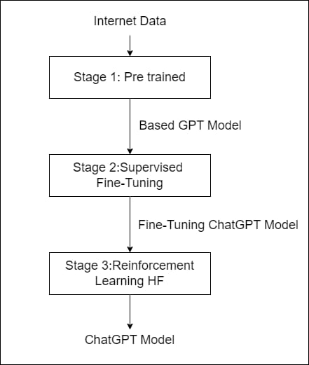

**Stage 1: Pre-Training**

The Pre-Training phase includes training a large amount of neural network on a vast amount of text data in an unsupervised manner. The introduction of the Transformer architecture has revolutionized this phase and it depends on the Transformer Architecture.

Transformer is a revolutionary core technology behind ChatGPT. It is based on the classical encoder-decoder architecture, self-attention, multi-head attention, positional embedding, and Feed-Forward Neural Network. Despite being based on the Transformer architecture ChatGPT does not utilize the encoder part of the Transformer Architecture.

Decoder: The decoder is trained to take the first token of the input sequence as a start token and then generate subsequent output tokens based on the input sequence and previously generated tokens.

Self-Attention module: It is the ability to capture complex dependencies between the tokens in an input sequence and efficiently determine the weight of each token in an input sequence, in addition to their relative importance. Self-Attention in Transformer also relies on the Query(Q), Key(K) and Value(V) concepts.

Multi-Head Attention: It is a module of the attention mechanism that is run through the attention mechanism several times. In this module, the self-attention mechanism is applied multiple times in parallel, each with its own set of learned weight matrices. This enables the model to focus on different parts of the input sequence simultaneously, thereby capturing various aspects of the input information. This approach often enhances the model's ability to understand and process complex sequences effectively.

Positional Embedding: It leverages position information to capture the order and importance of tokens in the sequence. The Transformer model creates an encoding for each position in the sequence and adds it to the token before passing it through the self-attention and feed-forward layers. In the Transformer architecture of ChatGPT, the positional embedding is added to the input embedding at the entrance of the decoder.

Feed-Forward Neural Network: Feedforward refers to the process of moving data forward through a neural network, beginning with the initial data input, progressing through intermediary layers where computations are performed, and culminating in the final output. This sequential flow ensures that information moves from the input layer, gets processed through various stages of computation, and eventually results in an output without any backward movement or loops.

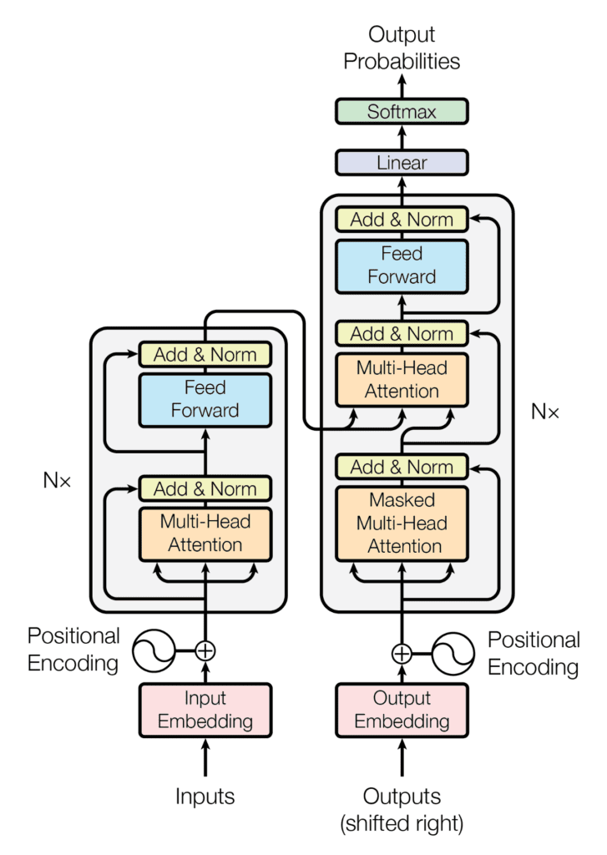

Fig: Transformer Architecture[10]

Overall, pre-training in the ChatGPT architecture involves training a large-scale generative language model on a diverse corpus of text data. This process enables the model to learn rich and generalizable representations of natural language, which can then be fine-tuned.

**Stage 2: Supervised Fine-Tuning**

The base GPT model which is pre-trained will pass through this stage i,e the Supervised Fine-Tuning. It involves refining the model's parameters and capabilities through exposure to specific examples or data in a supervised manner. This model has several stages like Task Definition, Data Collection, Model Adaptation, Fine-Tuning Process.

**Task Definition**: Fine-tuning begins by defining the specific task we want the model to excel at. This could be anything from answering customer inquiries to generating creative stories. The task defines the input-output behavior that the model needs to learn.

**Data Collection**: Relevant datasets are gathered for the fine-tuning task. These datasets contain examples of inputs (prompts or questions) and corresponding outputs (responses or answers) that the model needs to learn to generate effectively.

**Model Adaptation:** The pre-trained ChatGPT model is then adapted to the target task by fine-tuning its parameters. This involves updating the weights of the model's neural network using the examples in the fine-tuning dataset. The model learns to adjust its internal representations to better suit the nuances and requirements of the target task.

**Fine-tuning Process:** During fine-tuning, the model is exposed to the examples in the fine-tuning dataset, and its parameters are adjusted iteratively to minimize the difference between its predicted outputs and the true outputs provided in the dataset. This process typically involves techniques such as backpropagation and gradient descent to update the model's weights.

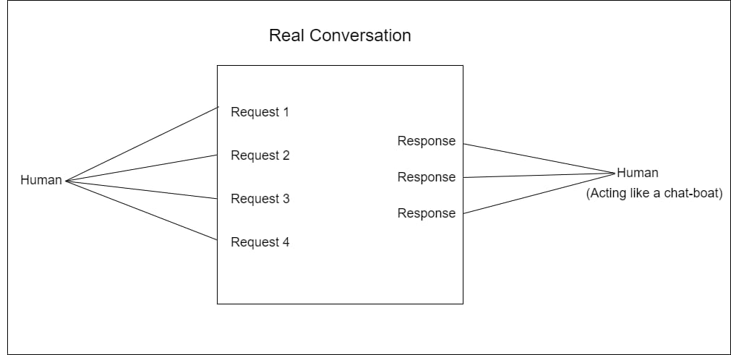

Throughout this stage, careful attention is paid to factors such as data quality, model interpretability, computational resources, and ethical considerations to ensure that the fine-tuned model performs effectively and responsibly in its intended application domain.

**Stage 3:Reinforcement Learning from Human Feedback**

Reinforcement Learning From Human Feedback (RLHF) is when we teach a computer program using a mix of a game-like learning method and feedback from people. Instead of just letting the computer learn on its own, we give it rewards, or corrections to help it learn faster and better. It's like having a coach guiding a player in a game to make better moves. This way, the computer learns to do tasks more like how humans would want it to.

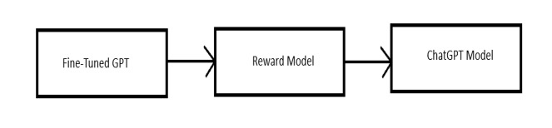

In this method, the fine-tuned GPT base is trained by giving reward points and corrections wherever needed, thus producing a reward model, the reward model is then optimized using reinforcement learning , giving the final ChatGPT model.

* **Potential of ChatGPT:**

ChatGPT and other similar AI have lots of potential in various domains. Some of them are:

**Conversation:** ChatGPT has the potential to revolutionize conversational interfaces, enabling more natural and engaging interactions between humans and machines. This can enhance customer service experiences, virtual assistants, and online chatbots, leading to improved user satisfaction and efficiency.

**Content Creation:** ChatGPT can be used to automate content creation across various mediums, including text, audio, and video. This can streamline content production processes for businesses, media organizations, and content creators, allowing them to generate high-quality and personalized content at scale.

**Creativity Enhancement:** ChatGPT can enhance creativity by generating ideas, concepts, and designs across various creative disciplines. It can assist artists, designers, and innovators in overcoming creative blocks, exploring new concepts, and pushing the boundaries of artistic expression.

**Language Translation:** ChatGPT's ability to understand and generate text in multiple languages makes it well-suited for language translation tasks. It can help break down language barriers and facilitate communication and collaboration between people from different linguistic backgrounds.

**Education and Training:** ChatGPT can be leveraged to create interactive and adaptive learning environments for students and professionals. It can provide personalized tutoring, feedback, and simulations across various educational domains, improving learning outcomes and knowledge retention.

**Research:** ChatGPT can accelerate research and innovation by analyzing vast amounts of data, generating hypotheses, and assisting in experimental design.

**Virtual Storytelling:** ChatGPT can be used to create interactive storytelling experiences in virtual environments, gaming, and entertainment.

**Medical Diagnosis:** ChatGPT can aid healthcare professionals in medical diagnosis by analyzing patient symptoms, medical records, and research literature to suggest potential diagnoses and treatment options. It can support clinical decision-making and improve patient outcomes.

**Legal Assistance:** ChatGPT can provide legal assistance by answering common legal questions, drafting legal documents, and conducting legal research. It can assist individuals and businesses in navigating legal issues more efficiently and affordably.

**Financial Planning:** ChatGPT can offer personalized financial planning advice based on individual financial goals, preferences, and risk tolerance. It can analyze financial data, market trends, and investment strategies to provide tailored recommendations for saving, investing, and budgeting.

Overall, the potential of ChatGPT is vast, spanning across industries, disciplines, and societal challenges. As AI technology continues to evolve, ChatGPT's capabilities are likely to expand, unlocking new possibilities and opportunities for innovation and growth.

* **Threats of ChatGPT:**

While ChatGPT and similar AI models offer numerous benefits, there are also potential threats and challenges associated with their deployment and usage, let us discuss some of the potential threats.

**Misinformation:** ChatGPT has the capability to generate human-like text, which can be exploited to spread misinformation and fake news at scale.

**Privacy Concerns:** ChatGPT relies on vast amounts of data to learn and generate text. If not properly managed, this data could include sensitive or personal information, leading to privacy breaches if misused or accessed by unauthorized parties.

**Bias and Discrimination:** AI models like ChatGPT may amplify biases present in the data they are trained on. This can result in biased or discriminatory outputs.

**Manipulation :** ChatGPT could be used to manipulate individuals by generating targeted messages to exploit their vulnerabilities or manipulate their emotions. This could be particularly concerning in contexts such as online scams or predatory behaviour.

**Security Risks:** There is a risk of ChatGPT being exploited for malicious purposes, such as generating phishing emails or crafting sophisticated social engineering attacks.

**Dependency and Degradation of Human Skills:** Overreliance on ChatGPT for communication or decision-making could lead to a degradation of human communication skills and critical thinking abilities.

**Regulatory and Legal Challenges:** The rapid advancement and widespread deployment of AI models like ChatGPT pose challenges for regulators and lawmakers in establishing appropriate frameworks to govern their use.

**Loss of Human Connection:** Excessive reliance on ChatGPT for communication and interaction may lead to a loss of genuine human connection and empathy. Over time, individuals may become accustomed to interacting with AI agents instead of real people, leading to social isolation and loneliness.

The threats require approach involving technological safeguards, ethical guidelines, regulatory oversight, and public awareness and education. It's essential to develop and implement responsible AI practices that prioritize the well-being of individuals and society while harnessing the benefits of AI technology.

* **GenAI**:

As Generative Artificial Intelligence(GenAI) laid the foundation of ChatGPT and various other Natural Language Processing Technology, it is essential to do an overview of GenAI. It was introduced in the 1960s in chatbots. It is a subset of Artificial Intelligence that are advanced in neural networks and can generate human-like text and other contents.

The architecture of GenAI is characterized by its complexity and sophistication, leveraging advanced algorithms and neural network structures to process and comprehend natural language. These architectures often involve deep learning models, such as recurrent neural networks (RNNs), transformer models, and generative adversarial networks (GANs), which enable GenAI systems to analyze large datasets and learn complex language patterns.

One of the key strengths of GenAI lies in its potential to facilitate automation and efficiency across various domains. In business and industry, GenAI can perform tasks such as customer service interactions, content creation, and language translation, leading to increased productivity and cost savings. Moreover, in education, GenAI can provide valuable support for students and educators by offering explanations, clarifications, and personalized learning experiences.

However, alongside its immense potential, GenAI also presents challenges and risks that must be addressed. These include concerns related to misinformation, biases, privacy risks, and ethical dilemmas. Responsible usage and ethical considerations are essential to mitigate these risks and ensure that GenAI systems benefit society while minimizing negative impacts.

Looking towards the future, the trajectory of GenAI is characterized by ongoing research and development efforts aimed at further advancing its capabilities and applications. Continued innovation in GenAI technology is expected to lead to enhanced performance, broader applications, and new opportunities for human-AI collaboration.

In summary, GenAI represents a transformative technology with vast potential to revolutionize communication, automation, and interaction with technology. By understanding its architecture, potential, and challenges, we can harness the power of GenAI to drive innovation and shape a positive future for artificial intelligence and society.

**Suggestion System**

As an AI language model, ChatGPT is continually being improved and refined based on user feedback and suggestions. However it’s not updated after 2022 and has limited data till 2022, ChatGPT requires the latest update.

There are also many cases and reports of the misinformation that the ChatGPT provides to the user, the precision of the data would beautify the work of ChatGPT.

**Conclusion**

In conclusion, the exploration of ChatGPT and Generative Artificial Intelligence (GenAI) throughout this term paper reveals the transformative potential and implications of these technologies. ChatGPT, with its evolution and advancements in natural language processing, presents a revolutionary tool that perform various tasks, enhances communication, and offers innovative solutions across diverse domains. Similarly, GenAI serves as the foundation for ChatGPT and various other language models, driving progress in artificial intelligence research and applications.

In the paper we investigate deep into the architecture of ChatGPT, which serves as the backbone for numerous language models and natural language processing applications. Through its complex architecture, ChatGPT enables the development of advanced AI systems capable of understanding and generating human-like text, revolutionizing communication and interaction with technology.

Throughout our examination, we have identified numerous applications and opportunities for ChatGPT and GenAI, spanning business, industry, education, and beyond. From customer service and content creation to language translation and educational support, these technologies offer promising avenues for automation, efficiency, and accessibility.

However, alongside their vast potential, it is imperative to recognize and address the challenges and ethical considerations associated with ChatGPT and GenAI. Threats such as misinformation, biases, ethical concerns, and potential misuse and mitigation strategies. Regulatory frameworks, transparency, and a commitment to ethical guidelines are essential to ensure that these technologies benefit society while minimizing negative impacts.

In conclusion, the study of ChatGPT and GenAI is ongoing and evolving, requiring continuous exploration, evaluation, and adaptation.

**Limitations**

This paper is based on the above 9 research papers that I have mentioned in the Literature Review section. Also as the field of AI continually evolves, staying updated on the latest advancements is crucial to remain informed and effective in leveraging its potential is essential. This paper remains as current as the date of writing.

**References**

[1]<https://scholar.google.com/scholar?hl=en&as_sdt=0%2C5&q=attention+is+all+you+need&oq=#d=gs_qabs&t=1714416158788&u=%23p%3D5Gohgn6QFikJ>

[2]<https://scholar.google.com/scholar?hl=en&as_sdt=0%2C5&q=a+brief+overview+of+chatgpt&btnG=#d=gs_qabs&t=1714415816051&u=%23p%3D2kPmYDOcRYUJ>

[3]<https://scholar.google.com/scholar?hl=en&as_sdt=0%2C5&q=a+brief+analysis+of+the+architecture%2C+limitations+and+impacts+of+chatgpt&btnG=#d=gs_qabs&t=1714416655419&u=%23p%3DWgTbUk7th10J>

[4]<https://scholar.google.com/scholar?hl=en&as_sdt=0%2C5&q=chatgpt+and+openai+models&btnG=#d=gs_qabs&t=1714416365550&u=%23p%3D-wx1wR9qj1sJ>

[5]<https://scholar.google.com/scholar?hl=en&as_sdt=0%2C5&q=can+chatgpt+understand+too%3F&btnG=#d=gs_qabs&t=1714416699487&u=%23p%3DpKZt32mKUUsJ>

[6]<https://scholar.google.com/scholar?hl=en&as_sdt=0%2C5&q=exploring+chatgpt&oq=explo#d=gs_qabs&t=1714417434124&u=%23p%3Dsmojw1ShoakJ>

[7]<https://scholar.google.com/scholar?hl=en&as_sdt=0%2C5&q=exploring+chatgpt+and+its+impact&btnG=#d=gs_qabs&t=1714417635809&u=%23p%3DNBzk5ix8knYJ>

[8]<https://scholar.google.com/scholar?hl=en&as_sdt=0%2C5&q=chatgpt+applications+opportunities+and+threats&oq=chatgpt%3A+applications+opportunities#d=gs_qabs&t=1714418010866&u=%23p%3D_Y2Cyb6AOEcJ>

[9]<https://scholar.google.com/scholar?hl=en&as_sdt=0%2C5&q=what+do+we+mean+by+genai&btnG=#d=gs_qabs&t=1714418061922&u=%23p%3DCuVoPxfjprYJ>

[10] <https://machinelearningmastery.com/wp-content/uploads/2021/08/attention_research_1-727x1024.png>